**Creating a RESTful API using express.js and creating a database and index in MongoDB.**

**Name**: Neela Bujji

**Roll No** : 20NN1A0530

**College** : Vignan’s Nirula Institute Of Techonology and Science For Women

**Source code** :

**Index.js file** :

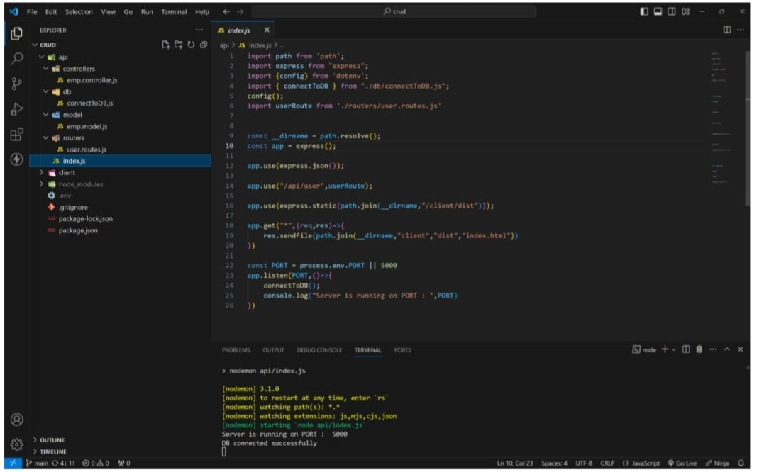

**MONGODB CONNECTION:**

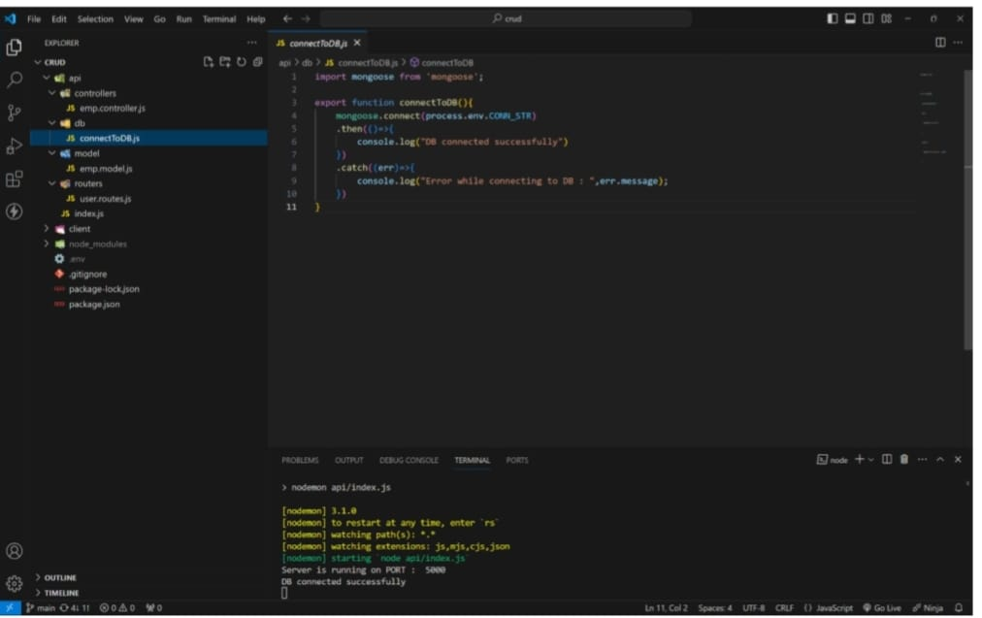

**MODEL :**

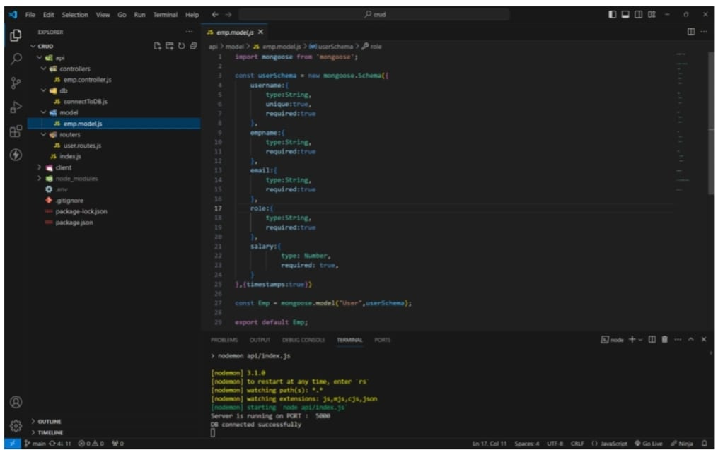

**ROUTES:**

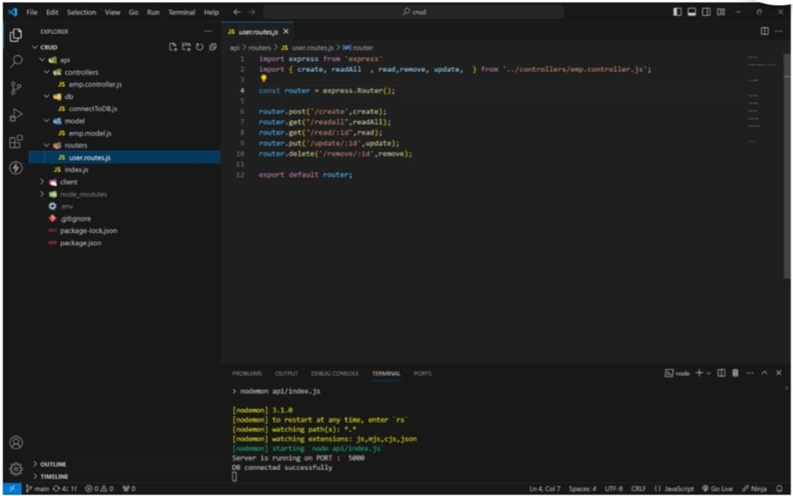

**CONTROLLERS :**

**CREATE :**

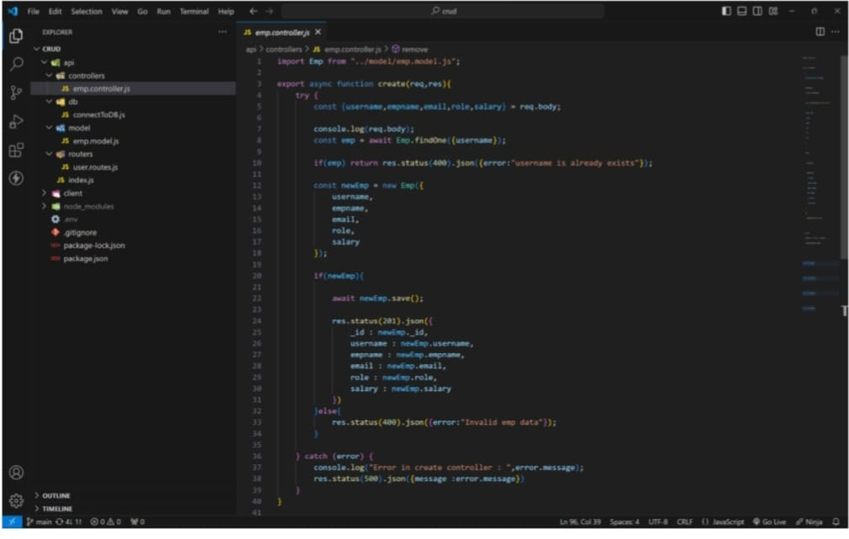

**READALL :**

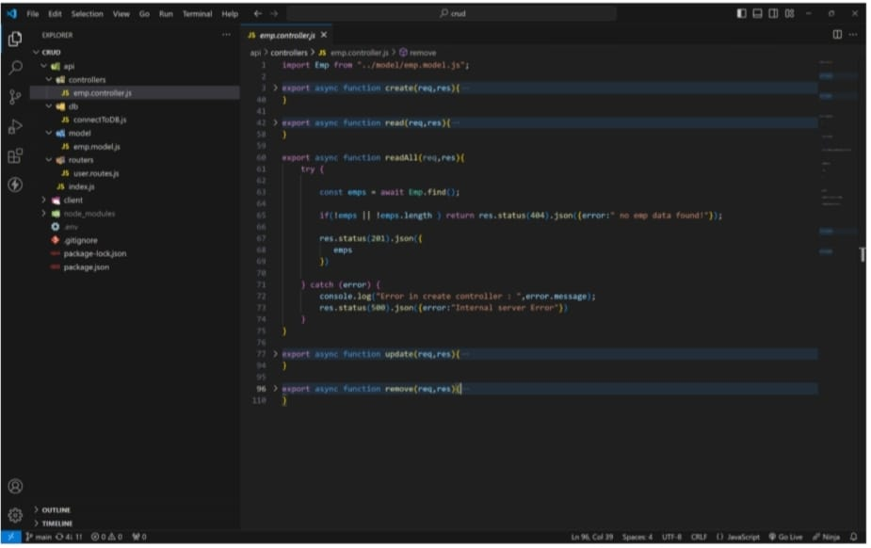

**READONE :**

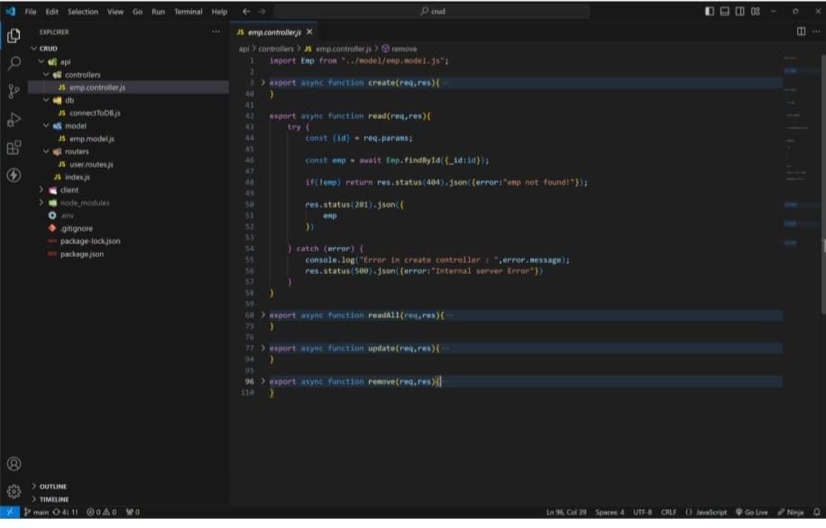

**UPDATE:**

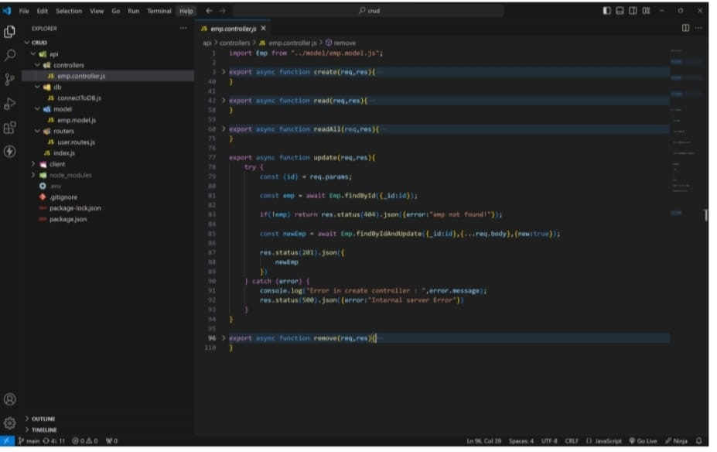

**DELETE :**

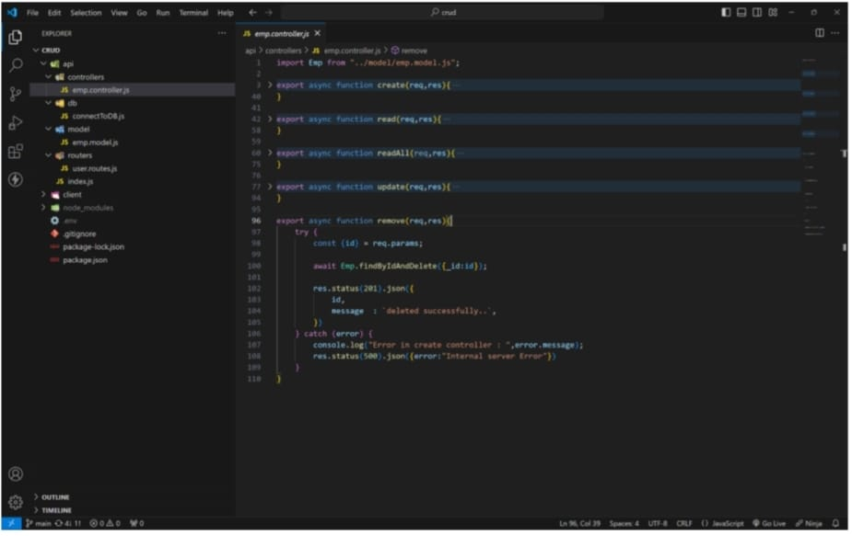

**HOW TO RUN ON LOCALLY :**

1. **Create a folder as any name.**
2. **Open that folder in any code editor (vs code)**
3. **Open terminal (ctrl + ~) on code editor.**
4. **Type this code to get code locally.**
5. **Now move to crud folder (cd crud in terminal)**
6. **Ignore client folder.**
7. **Here crud is root folder.**
8. **In root folder create a .env file and create a PORT and**

**CONN_STR variables and assign value.**

**Ex : PORT =3000 (commonly any number between 3000-8000).**

**CONN_STR = your mongodb_connection_string.**

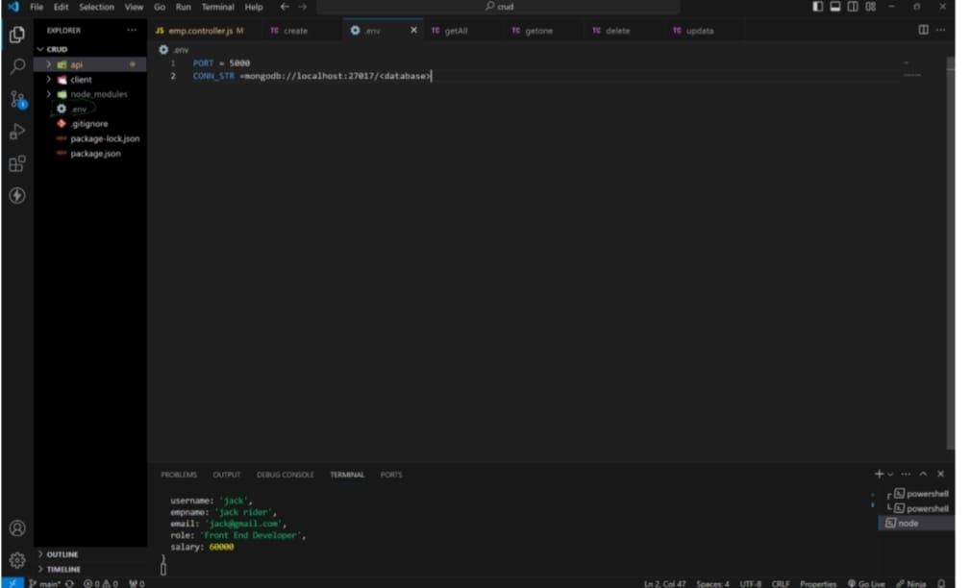

**---trouble in above process ? :**

**Simply paste this code in .env file**.

PORT =5000

CONN_STR=mongodb+srv://

1. **After in terminal (in crud folder as root folder) type this command to run server.**

**npm I (installing all dependencies)**

**npm run dev (to run server)**

1. **If you get below messages in terminal then your serever will running successfully**.

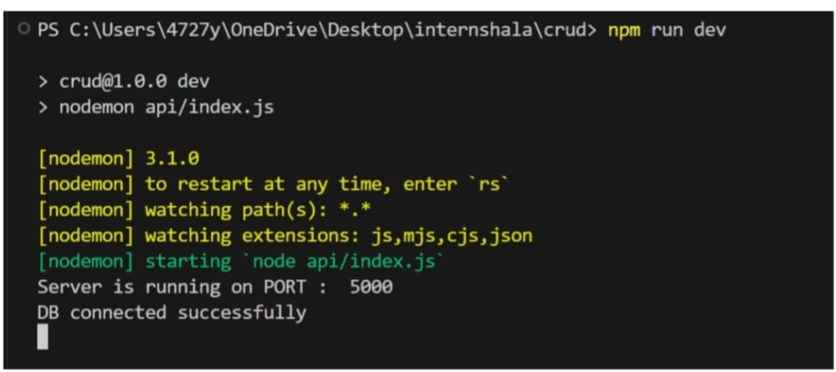

**Route and its functionality :**

**For this use any API using tools like Postman or Thunder Client.**

**I use THUNDER CLIENT.**

**CREATE ROUTE :**

**1.This route is used to create a new employee in database with a below fields.**

**Username, empname, email, role, salry**

**2.In thunder client click on new request and slect this options method as post**

url as <http://localhost:5000/api/user/create>

pass this json ddata as a body as your required value.

{

“username”: “jack”,

“empname”: “jacl rider”,

“email”: [jack@gmail.com](mailto:jack@gmail.com),

“role”: “Front End Developer”.

“salary”: “60000

}

**3.Finally press send to insert data in mongodb data base and get a inserted**

**Data as a response.**

**4.If user is already in db it will return User is already exist as response.**

**For more details visit below output images….**

**READONE :**

1. **This route is used to read specific user info by passing that user id as a param.**

**Method as get**

url as

<http://localhost:5000/api/user/read/65edb3d76e1dcc9a51654ca>

1. **After sending you will get that specific user details as response.**

**READALL :**

1. **Read all route is used to get all the user data existing in the mongodb data base.**

**Method as get**

**url as** <http://localhost:5000/api/user/readall>

1. **After sending you will get that all user details as response.**

**UPDATE :**

1. **This route is used to update specific user by passing that user id as a param.**

**Method as put**

**url as**

<http://localhost:5000/api/user/update/65ed7b3d7e1dcc9a51654ca>

1. **After sending you will get updated user details as response.**

**DELETE :**

1. **This route is used to delete psecific user by passing that user id as a param.**

**Method as delete**

**url as**

<http://localhost:5000/api/user/delete/65ed7b3d76e1dcc9a51654ca>

1. **After sending you will deleted successfullya s response**

**OUTPUT :**

**CREATE A NEW USER:**

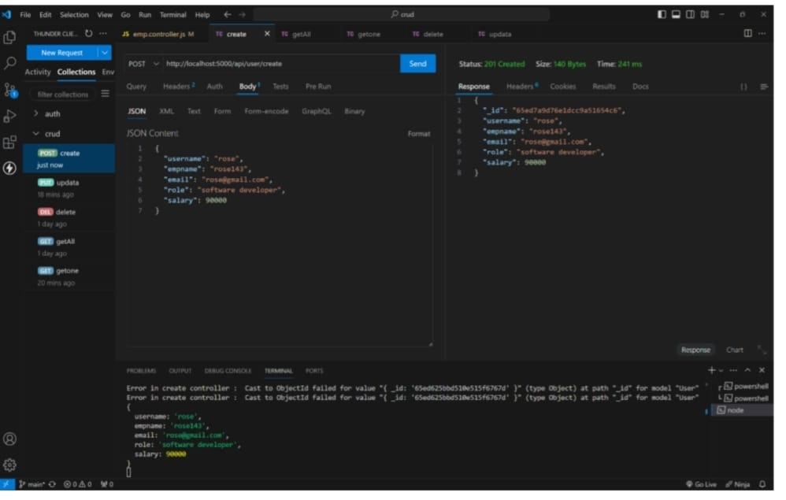

**CREATING USER WITH EXISTING USERNAME :**

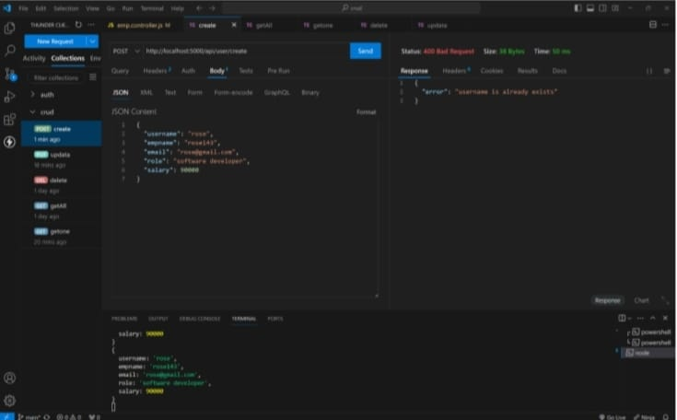

**READONE :**

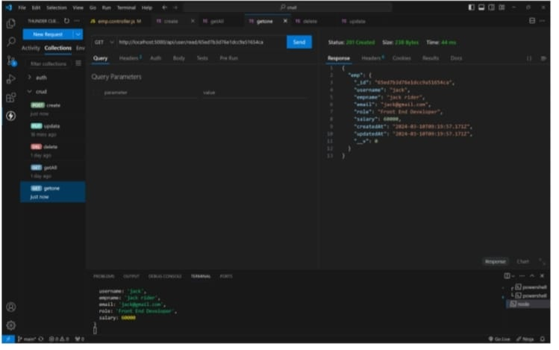

**READ ALL :**

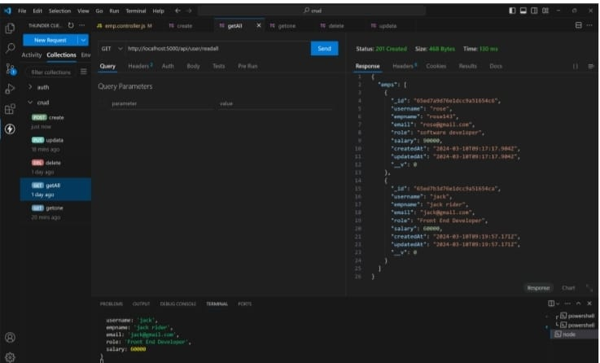

**UPDATE :**

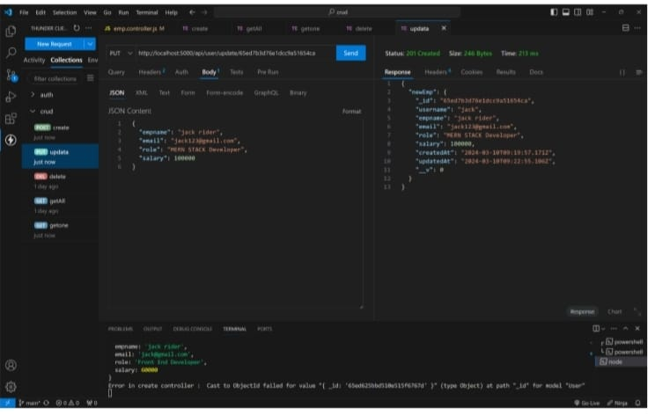

**DELETE :**

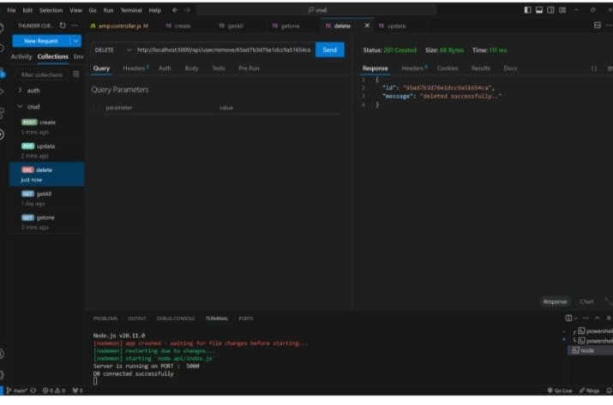

**SOURCE CODE :**

**LIVE DEMO :**